Name – Sayak Sen

Enrollment No – 2023CSB047

Assignment Sheet – 1

Assignment 1

Creation of the tables:

1.Depts Table

create table depts(

    deptcode varchar(3) primary key,

    deptname varchar(30) not null

);

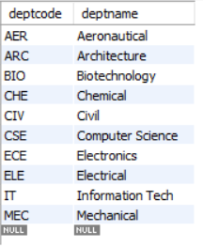

2.Students Table

CREATE TABLE students (

    rollno INT PRIMARY KEY,

    name varchar(30),

    bdate date check (bdate < '1997-01-01'),

    deptcode varchar(3),

    hostel int check (hostel < 10),

    parent_inc decimal(8,1),

    FOREIGN KEY (deptcode) REFERENCES depts(deptcode) ON DELETE CASCADE

)

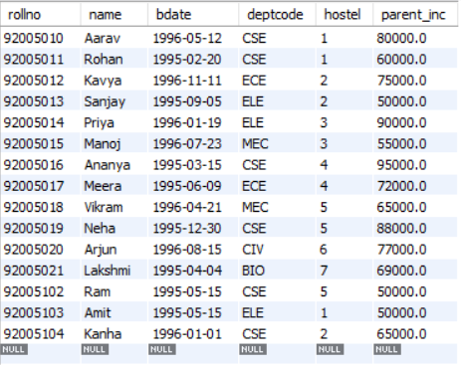

2.Faculty Table

create table faculty(

    fac_code varchar(8) primary key,

    fac_name varchar(30) not null,

    fac_dept varchar(3),

    foreign key (fac_dept) references depts(deptcode)

);

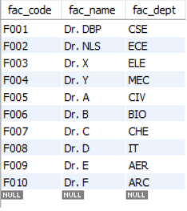

4.Course Offered Table

create table crs_offrd(

    crs_code varchar(5) primary key,

    crs_name varchar(35) not null,

    crs_credits decimal(2,1),

    crs_fac_cd varchar(8),

    foreign key (crs_fac_cd) references faculty(fac_code)

);

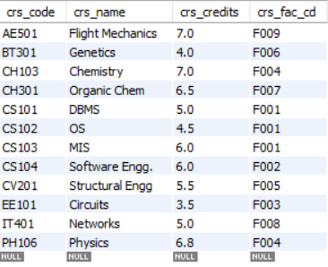

5.Course Registered Table

create table crs_regd(

    crs_rollno int,

    crs_cd varchar(5),

    marks decimal(5,2),

    primary key(crs_rollno, crs_cd),

    foreign key (crs_rollno) references students(rollno),

    foreign key (crs_cd) references crs_offrd(crs_code)

);

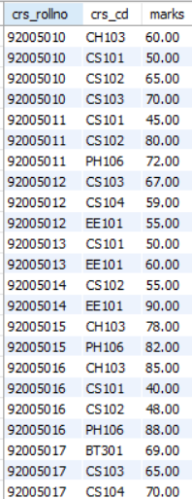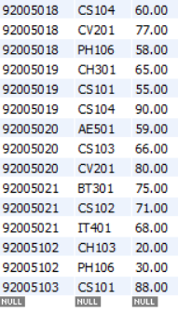

Queries

**1.Inserting Queries that violate the constraints**

insert into students values(92005010,'John Doe','2000-05-15','CSE',1,50000);



**2. Delete records from dept where deptcode='CSE'.**

delete from students where deptcode = 'CSE';

Before deleting :



After Deleting :

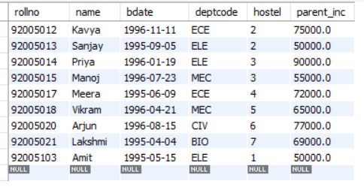

After deleting i re-inserted the values for future queries that require CSE students.

**3.Find out the courses offered by the faculty dbp and nls.**

select faculty.fac_code, faculty.fac_name, crs_offrd.crs_code, crs_offrd.crs_name, crs_offrd.crs_credits

from faculty JOIN

crs_offrd ON faculty.fac_code = crs_offrd.crs_fac_cd where faculty.fac_name = 'Dr. NLS' or faculty.fac_name = 'Dr. DBP';

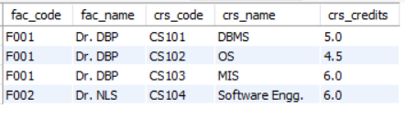

**4.Find out the courses with full details offered by dbp.**

select faculty.fac_code, faculty.fac_name, faculty.fac_dept, crs_offrd.crs_code, crs_offrd.crs_name, crs_offrd.crs_credits

from faculty

JOIN

crs_offrd ON faculty.fac_code = crs_offrd.crs_fac_cd where faculty.fac_name = 'Dr. DBP';

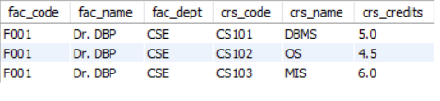

**5.Get the courses the credits of which lies between 4.0 and 6.0.**

select crs_name,crs_credits from crs_offrd where crs_credits between 4.0 and 6.0;

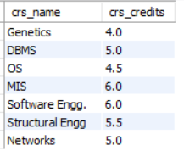

**6.Get the courses the credits of which are > 6.5.**

select crs_name , crs_credits from crs_offrd where crs_credits>6.5;

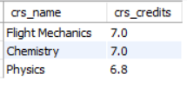

Assignment 2

**1.Count the number of students in CSE dept.**

select count(*) from students where deptcode = 'CSE';



**2.Determine the minimum, maximum and average marks of each courses.**

select crs_cd,min(marks) as MinMarks,max(marks) as MaxMarks,avg(marks) as AvgMarks from crs_regd group by crs_cd;

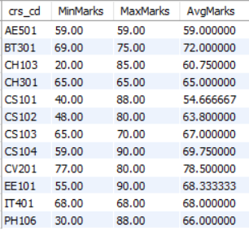

**3.Determine the total credits of the courses registered by a student.**

select crs_rollno,sum(crs_credits) as total_credit from crs_offrd

join crs_regd on crs_offrd.crs_code = crs_regd.crs_cd group by crs_rollno;

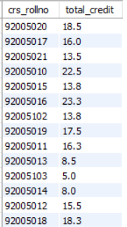

**4.Count the number of students in each hostel whose department is CSE.**

select hostel , count(*) as cse_students from students where deptcode = 'CSE' group by hostel;

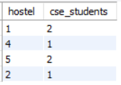

**5.Display the hostel,rollno,parent_inc of the student**

**who has the max(parent_inc) in a hostel.**

select rollno,hostel,parent_inc from students as s where parent_inc = (select max(parent_inc) from students where hostel = s.hostel);

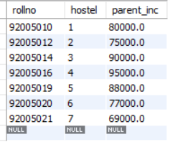

**6.Display the name and parental income of each student greater than the parental income of some rollno 92005010.**

select name , parent_inc from students where parent_inc >(select parent_inc from students where rollno = 92005010);

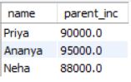

**7.Find out marks of students who have marks more than**

**rollno 92005102 for course CH103 and PH106.**

select * from crs_regd where (crs_cd = 'CH103' and marks > (select marks from crs_regd where crs_rollno = 92005102 and crs_cd = 'CH103'))

UNION

select * from crs_regd where (crs_cd = 'PH106' and marks > (select marks from crs_regd where crs_rollno = 92005102 and crs_cd = 'PH106'));

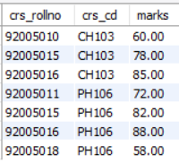

Assignment 3

**1.List students (rollno,name,deptcode) registered for course EE101.**

select rollno,name,deptcode from students

join crs_regd on students.rollno = crs_regd.crs_rollno

where crs_cd = 'EE101';

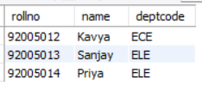

**2.List students (rollno,name) in ELE dept registered for course EE101.**

select rollno,name from students

join crs_regd on students.rollno = crs_regd.crs_rollno

where deptcode = 'ELE' and crs_cd = 'EE101';

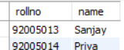

**3.List students (rollno,name) in ELE dept not registered for course EE101.**

select rollno,name from students

join crs_regd on students.rollno = crs_regd.crs_rollno

where deptcode = 'ELE' and rollno not in (select crs_rollno from crs_regd where crs_cd = 'EE101');



**4.List the names of the students who have registered for both the courses 'DBMS' and 'OS'.**

select name from students

join crs_regd on crs_regd.crs_rollno = students.rollno

join crs_offrd on crs_regd.crs_cd = crs_offrd.crs_code

where crs_name in ('DBMS','OS')

group by rollno

having count(DISTINCT crs_name) = 2;

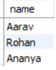

**5.Find the names of the faculty members who have offered either 'MIS' or 'Software Engg.'**

select fac_name from faculty

join crs_offrd on faculty.fac_code = crs_offrd.crs_fac_cd

where crs_name = 'MIS'

UNION

select fac_name from faculty

join crs_offrd on faculty.fac_code = crs_offrd.crs_fac_cd

where crs_name = 'Software Engg.';

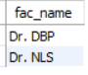

**6.Find the names of the faculty members who have offered 'MIS' but not offered 'Software Engg.'**

select fac_name from faculty

join crs_offrd on faculty.fac_code = crs_offrd.crs_fac_cd

where crs_name = 'MIS'

EXCEPT

select fac_name from faculty

join crs_offrd on faculty.fac_code = crs_offrd.crs_fac_cd

where crs_name = 'Software Engg.';



**7.Find out the students in each hostel who are not registered for any course.**

select name,hostel from students

where rollno not in (select crs_rollno from crs_regd);



**8.Select the students who are in ELE dept or who have registered for course CS101.**

select rollno,name,deptcode from students

where deptcode = 'ELE'

UNION

select rollno,name,deptcode from students

join crs_regd on students.rollno = crs_regd.crs_rollno

where crs_cd = 'CS101';

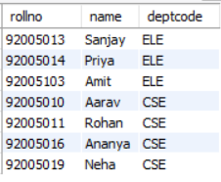

**9.Display the students who have registered to all the courses.**

select rollno,name,deptcode from students

join crs_regd on students.rollno = crs_regd.crs_rollno

group by rollno having count(crs_cd) = (select count(*) from crs_offrd);



**10.Give Grace Marks 5 in subject ‘DBMS’to the students who have scored less than 50 in that subject.**

update crs_regd

set marks = marks + 5

where crs_cd = (select crs_code from crs_offrd where crs_name = 'DBMS') and marks < 50;

